COMSATS UNIVERSITY ISLAMABAD

Attock Campus


Department Of Computer Science

Course | Information security
Instructor | Maam Ambreen
lab | mid

Submitted From:

Registration No | Name
SP24-BSE-030 | Zuhaib Shahid

Question 1:Caesar Cipher
Write a Python program that encrypts a message using the Caesar Cipher with a user-given shift value.
Example:
Enter message: hello
Enter shift: 3
Ciphertext: khoor
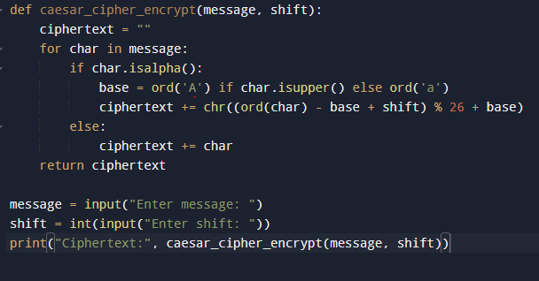

Output
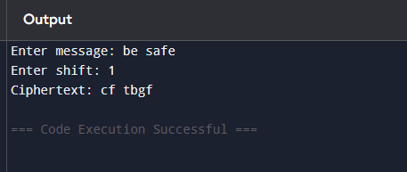

Question 2:Vigenère Cipher (Encryption Only)
Write a Python program to encrypt a plaintext message using the Vigenère Cipher.
Ask the user for plaintext and keyword.
Display the ciphertext only.
Example:
Enter plaintext: ATTACKATDAWN
Enter key: LEMON
Ciphertext: LXFOPVEFRNHR

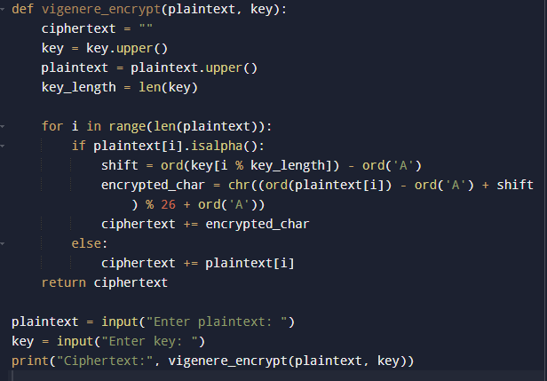

out put
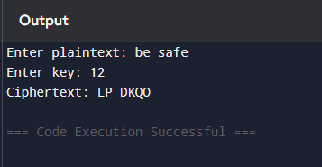

Question3Debugging Task (Simple XOR Encryption)
The following program is supposed to perform XOR encryption, but it contains an error. Fix the mistake so that it correctly shows the ciphertext.
def xor_encrypt(text, key):
result = ""
for i in range(len(text)):
result += chr(ord(text[i]) ^ ord(key)) # Error in code
return result
text = input("Enter message: ")
key = input("Enter single character key: ")
print("Ciphertext:", xor_encrypt(text, key))

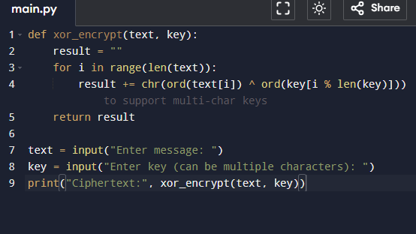

Out put
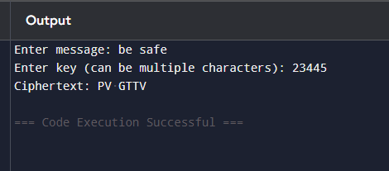

Question 5DES and AES
Answer briefly:
a) One difference between DES and AES. (2 marks)
b) AES block size and one key size. (2 marks)
c) One reason why AES is more secure than DES. (1 mark)

a) Key distinction between DES and AES
DES (Data Encryption Standard):
Uses a 56-bit key.
Encrypts data in 64-bit blocks.
Older encryption standard (developed in the 1970s).
AES (Advanced Encryption Standard)
Uses 128-bit blocks.
Supports key sizes of 128, 192, or 256 bits.
More modern and secure than DES.
Main Difference:
AES allows larger keys and blocks, making it stronger and more resistant to attacks compared to DES.

b) AES block size and example of its key size
AES always uses a fixed block size of 128 bits.
AES can use three key sizes:
128 bits
192 bits
256 bits
Example:
AES-256 uses a 256-bit key, providing very strong encryption security.

c) Why AES is more secure than DES
Longer key length:
AES keys (128–256 bits) are much longer than DES’s 56-bit key.
Resistance to brute-force attacks:
Longer keys mean it would take an extremely long time (virtually impossible) to guess the key.
Modern design:
AES is based on more advanced mathematical algorithms than DES.
Wider adoption and reliability:
AES is the current encryption standard recommended by the U.S. government and used worldwide.

